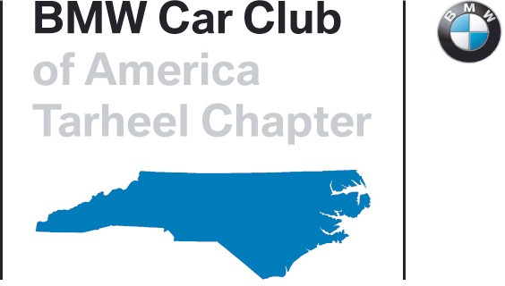
Tarheel Chapter BMW CCA
Guest Instructor Application

Thank you for your interest in being a Guest Instructor with the Tarheel Chapter BMW CCA. Our Chapter welcomes the addition of experienced, enthusiastic instructors from other clubs as our staffing requirements allow. To be considered for inclusion in our next or future events, please review the following steps and submit the attached application to the Guest Instructor Coordinator.

Minimum requirements for "Guest" Tarheel Chapter instructors:

- Guest instructors must be seasoned and experienced instructors that are known & recommended by the Chief Instructor of their respective chapter, and other organizations for whom they have instructed.
- Guest Instructors must register for and attend the Friday Instructor day, unless they have written permission from the Chief Instructor. Fees for Friday will be collected as described in the registration documents.
- Guest Instructors instructing for the first time are required to take the Tarheel Continuing Education seminar on Friday, if offered that weekend. Participants will receive a partial refund on their Friday fee if attendance is verified.
- All cars participating Saturday and Sunday must have a passenger seat and safety restraints must be equal.
- Instructors must have a working communicator for in-car communications with your student.
- A Snell (SA, M, or K rated) 2015 or newer helmet is mandatory.
- Long sleeve shirts are typically required, but this may be waived by VIR. Come prepared for either long or short shirts. Long pants are required.
- Instructors may self tech their vehicle, but a Tarheel tech sheet is required at registration.
- The Instructor confirmation packet is found at http://tarheelbmwcca.org/track.html

- Please fill out the Guest Instructor Application on the following page. Please give us as much information as you can, we do check your logbooks and other online information, so the more up to date that is, the fewer questions we will ask. We will check with your references and your Chief Instructor.

Guest Instructor Application

Name:

Email address:

motorsportreg.com email address (if different):

Evening Phone Number:

Daytime Phone Number:

Mobile Phone Number:

Your References:

BMWCCA Chapter of record (if any):

BMWCCA Chapters for whom you have instructed:

Other Organizations for whom you have instructed:

Driving experience at VIR (how often, which configurations, when): How long have been Instructing?
Have you taken Instructor Training, and if so with whom and when?

References: Please include name and a current email address for each reference:

You may attach a driving resume if available

Comments or Questions?

Yes, I read all the requirements on page one and understand them.

Please email this application to instructordevelopment@tarheelbmwcca.org.

1/25/22

