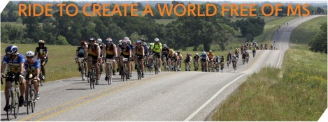
Calling all BMW Club Cyclists.
Join us for a fun Bike ride this fall to benefit a great charity, the National MS Society.
The Tarheel Chapter is sponsoring a cycling team for the Tour to Tanglewood, 2-day bike ride this September. The ride will be on Saturday and Sunday September 26 and 27, 2026.
We guarantee you will have a great time with some BMW friends and will also feel great helping out a very worthy cause, the MS Society.
Use the following link to join the Tarheel Chapter Team or to make a donation:
https://events.nationalmssociety.org/2752
For more information and a discount code for registration contact:
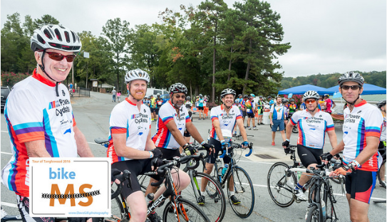
Tom Tice
(teticem3@gmail.com)

