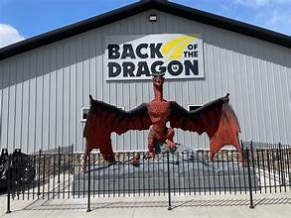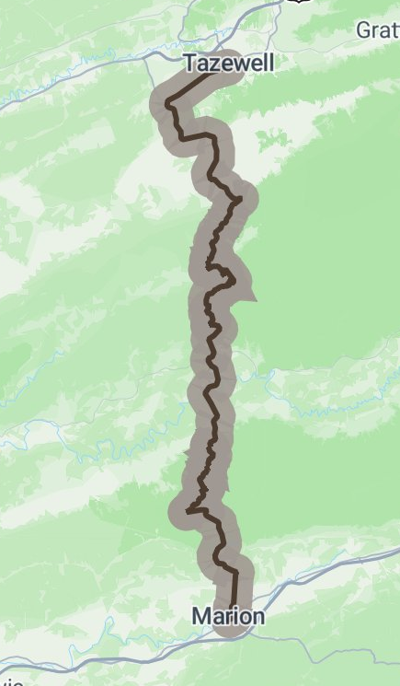

The Back of the Dragon Driving Tour for the Roanoke Area group will take place on Tuesday, September 15th, driving from Salem, VA to the "Back of the Dragon", with stops in Pearisburg, Burke's Garden, and Tazewell, and finishing with lunch at Macado's in Marion.

The first leg will take us from the Park-and-Ride in Salem via 311, Mount Tabor Rd, and 460 to McDonalds in Pearisburg for a short pit stop. The second leg will include Route 61 along Wolf Creek past Rocky Gap, turning up Rt 623 to Mountain View Market in Burke's Garden for cinnamon rolls. The third leg includes a tour of Burke's Garden, then back down to Route 61 and on to Tazewell for a souvenir and photo-op stop at the Back of the Dragon visitor's center. And the fourth leg will take us to Marion via Route 16, better known as Back of the Dragon. The tour will finish with lunch at Macado's in Marion.

Here are the details:

Date: Tuesday, September 15th, 2026
Meeting place: Park and Ride near Salem at the intersection of I-81 and Rt 311 NW side of the interstate)
Meeting time: Be there gassed up with coffee in hand no later than 7:30 AM. I will go over the rules of the road, hand out directions, and circulate the waiver for signatures.
Departure time: Right at 7:45 AM
Total mileage: 156 miles from Salem to Marion
Estimated driving time: 4 hrs 10 min
Breaks: 3 Pearisburg (McDonald's), Burke's Garden (Mountain View Market), and Tazewell (the Back of the Dragon visitor's center).
Longest segment: 1 hr 20 min
Lunch: 1:15 PM at Macado's in downtown Marion. This is the end of the tour.
Return route: on your own
Estimated time to depart Marion after lunch: 2:30 PM (1 hr 30 min to get back to Salem via I-81)

Please respond to this email by Friday, September 11th if you are planning to participate. Feel free to email or call me if you have any questions at roanoke.tarheel.bmwcca@gmail.com

Come on out and join us while we enjoy the late summer weather, beautiful countryside, good company, and driving some of the most challenging roads in the region.
Scott Donaldson, Roanoke Area Coordinator, Tarheel Chapter, BMW CCA,540-953-2565

